UNIVERSITI TEKNOLOGI MARA CAWANGAN KEDAH

KAMPUS SUNGAI PETANI,KEDAH

SCHOOL OF INFORMATION SCIENCE

COLLEGE OF COMPUTING,INFORMATICS AND MATHEMATICS

DIPLOMA IN LIBRARY INFORMATICS

(CDIM144)

PROGRAMMING FOR LIBRARY

(IML 208)

ASSIGNMENT 1 : (INDIVIDUAL PROJECT)

PREPARED BY :

MOHAMAD HAZIM BIN OTHMAN (2023866356)

PREPARED FOR :

MOHD FIRDAUS BIN MOD HELMI

SUBMISSION DATE :

WEEK 10

**ACKNOWLEDGEMENT**

Assalamualaikum W.B.T

Alhamdulillah, first of all I would like to thanks to Allah S.W.T our greatest God for giving me a strength to complete this assignment very well and also succed.

I, as a part of student from CDIM144 Library Informatics would like to thank to my best lecturer Sir Firdaus for helping me during the time I wanted to complete this assignment. He always open to answer my question when I don’t understand something related to this assignment. Without his guidance, I could not finish this assignment completely by myself.

Apart from that, I would like to thank all my beloved friends and also my classmates for willing helping me without any hesitation throughout this assignment. They always responsive and ready to help if I ask question about assignment.

Last but not least, I would like to thank to my parents even though they far away but they still pray and give support so that I do not feel like a failure and give up in completing this assignment. Also, all that involved directly or indirectly in this assignment.

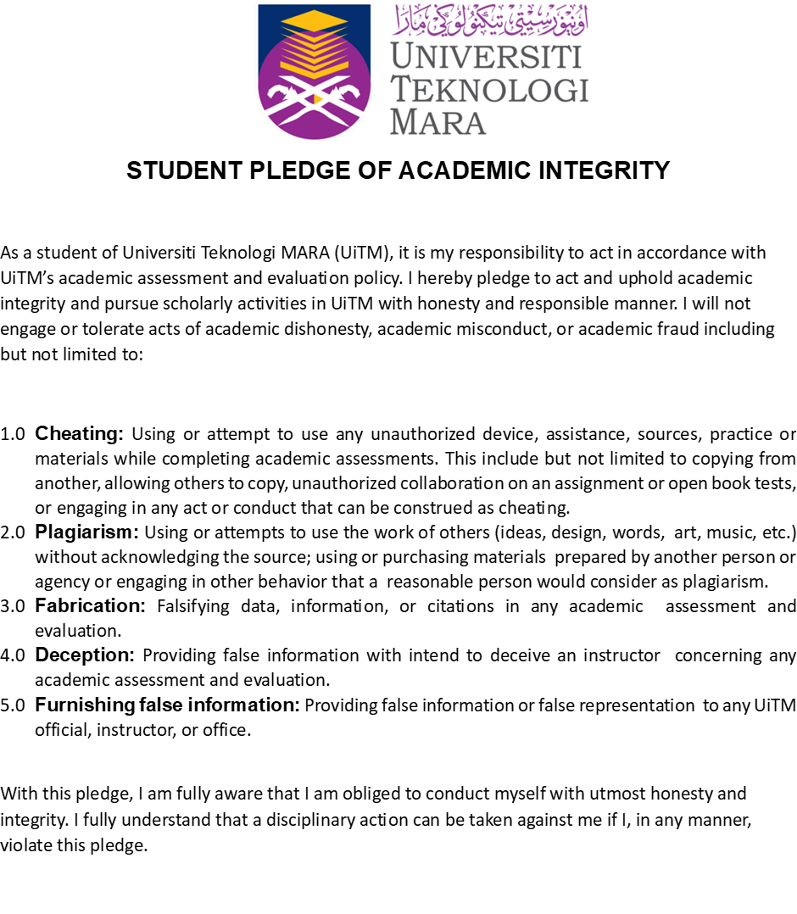



Name: MOHAMAD HAZIM BIN OTHMAN

Matric Number: 2023866356

Course Code:  IML206

Programme code: IM144

Faculty / Campus: UITM SUNGAI PETANI

*Students are required to sign one pledge for each course taken

**TABLE OF CONTENT**

|  |  |
| --- | --- |
| **CONTENT** | **PAGE** |
| 1. PROJECT NAME  * FILE NAME * PROMPT DATA | **1** |
| 2.0 FUNCTION   * CREATE DATA * READ DATA * UPDATE DATA | **2** |
| 3.0 CONDITIONAL STATEMENT | **3** |
| 5.0 RESULT | **4** |
| 6.0 STRENGHT | **5** |
| 7.0 KAIZEN | **6** |

**PROJECT NAME :** Train Ticket Booking System

**FILE NAME :** train ticket booking system.py

**PROMPT DATA :**

1. Name : Platinum, Gold and Express line
2. Place / Destination : Kangar, Kota Bharu and Johor Bahru
3. Price : RM120, RM100 and RM90

**FUNCTION :**

1. **Create Data**

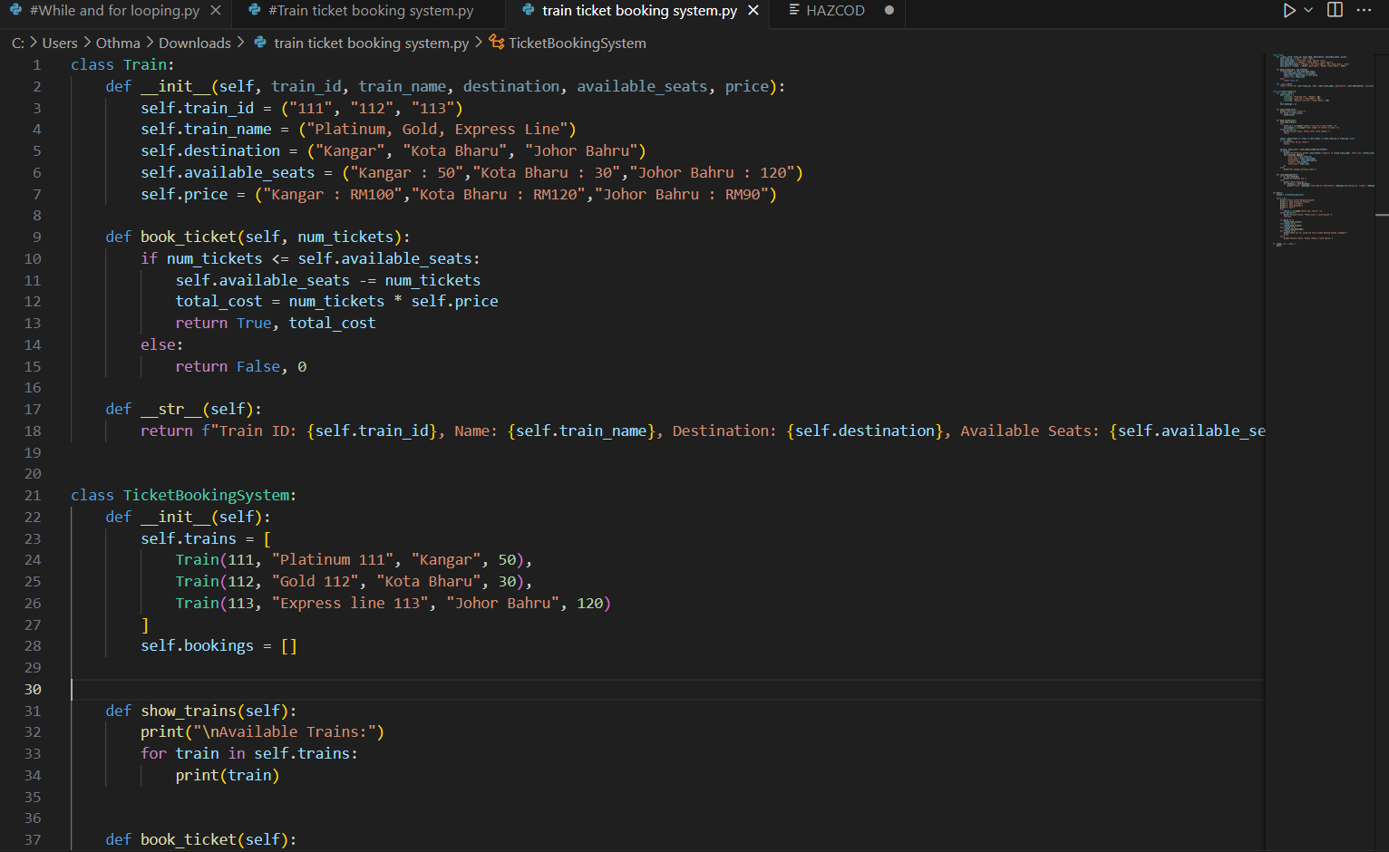

Figure 1

1. **Read Data :**

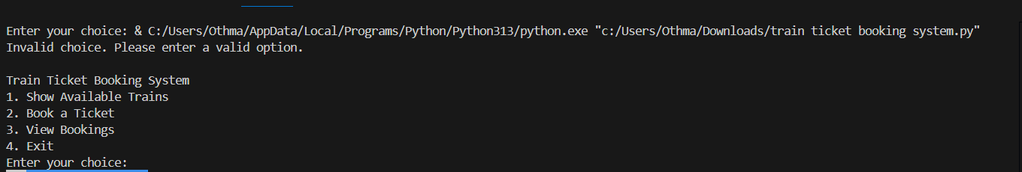

**Figure 2**

1. **Update Data :**

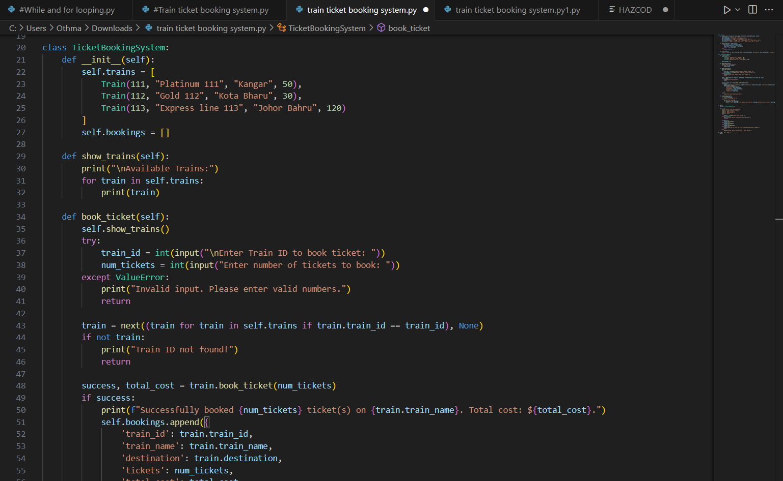**Figure 3**

**CONDITIONAL STATEMENT :**

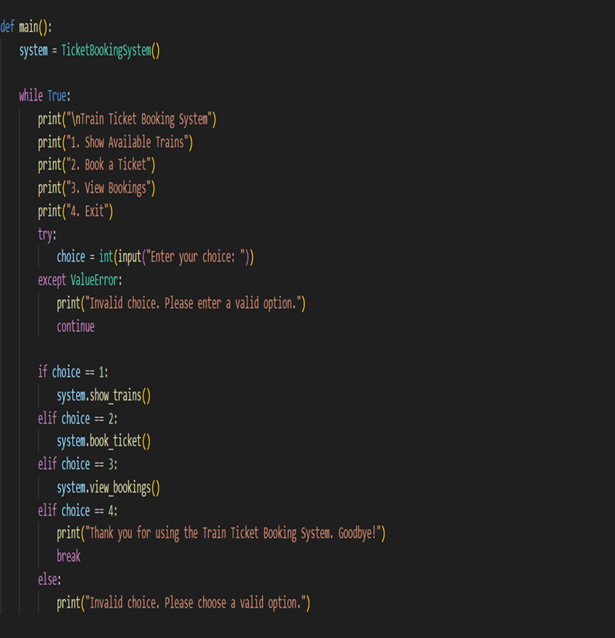

**GUI : NO**

**RESULT :**

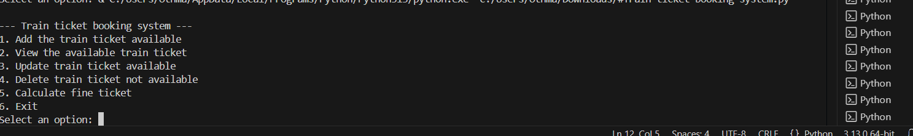

**STRENGTH :**

* The system will be open 24 hours for customer to booking
* The price will automatically offer to customer
* Customer will get the ticket directly after finish booking

**KAIZEN :**

* Add more interesting place that must have to visit
* Provide more payment method in purchase option
* Make sure put a helpline so customer can contact to need help